Table 1 — APPN HiRES Mission Standard Type Settings.
APPN parameter bundles for the four APPN HiRES Mission Standard Types using the DJI Pilot 2.

Standard Mission Type | Scenario | Altitude / Speed / Shutter / Overlap
Type 1 | Plant counting / small structures  (flowers, heads, early lesions, emergence counting) | Alt: 12–20 m · Speed: 0.9–1.6 m/s (Faster speeds may be used at specific altitudes) · Shutter: ≥1/4000 · Aperture: f/8 Overlap: 80/80 ·
Type 2 | Plot phenotyping  (canopy traits, vigour) | Alt: 30–50 m · Speed: 2.4–4.1 m/s (Faster speeds may be used at specific altitudes) · Shutter: ≥1/4000 · Aperture: f/8 Overlap: 80/80
Type 3 | Canopy coverage / plot averages | Alt: 50–70 m · Speed: 4.1–5.7 m/s (Faster speeds may be used at specific altitudes) · Shutter: ≥1/4000 · Aperture: f/8 Overlap: 80/80
Type 4 | Large-area flat terrain ortho  (efficiency mode) | Alt: 80–120 m · Speed: 6.5–9.8 m/s (Faster speeds may be used at specific altitudes) · Shutter: ≥1/4000 · Aperture: f/8 Overlap: 80/80

Shutter (and flight) Speed, Aperture and ISO Exposure Control
In constant light conditions, the most consistent image capture will come from setting a fast shutter speed (to prevent motion blur) and an aperture that allows for a moderate depth of field (of focus) while maintaining a fast shutter speed. DJI Pilot 2 mission planning will always set a conservative shutter speed setting that does not allow for image motion blur. Set a minimum shutter speed of 1/4000 s across all operating scenarios and always use an aperture of f/8 due.
ISO is the only variable parameter used to achieve the correct exposure and a balanced histogram. The minimum ISO available on the camera is ISO 200, and the maximum recommended ISO is ISO 3200 to avoid introducing excessive image noise.
As a general reference, under clear sky conditions around solar noon, the expected ISO value may be around ISO 1250, although this will vary depending on actual lighting conditions, cloud cover, crop reflectance, altitude, and mission timing.
To check and set the correct exposure before starting the mission:
- Set minimum shutter speed of 1/4000 s and aperture of f/8 in DJI Pilot 2 Camera settings.
- Fly the aircraft to the area of interest at the proposed mission altitude.
- Point the camera over the target crop or survey area(nadir or straight down).
- Review the live histogram (bottom left of controller screen).
- Adjust the ISO using the exposure control (+ / -) buttons on the right-hand side of the controller screen.
- Continue adjusting until the histogram shows a suitable exposure without clipping at either end.
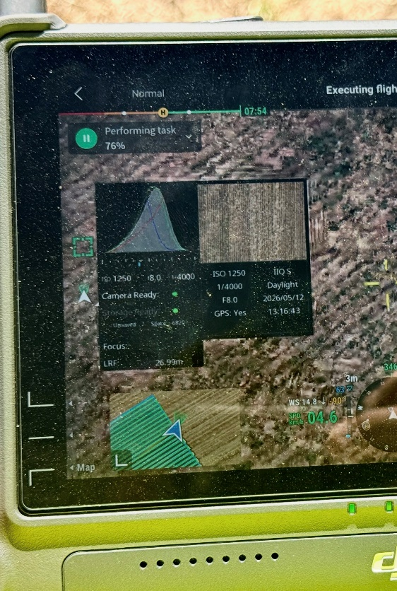
A correctly exposed histogram may appear as a single smooth peak, or as a series of peaks and valleys. Both are normal, depending on the scene. The key point is to monitor the left and right edges of the histogram and avoid clipping, particularly on the right side, where overexposed highlights may result in lost image detail.
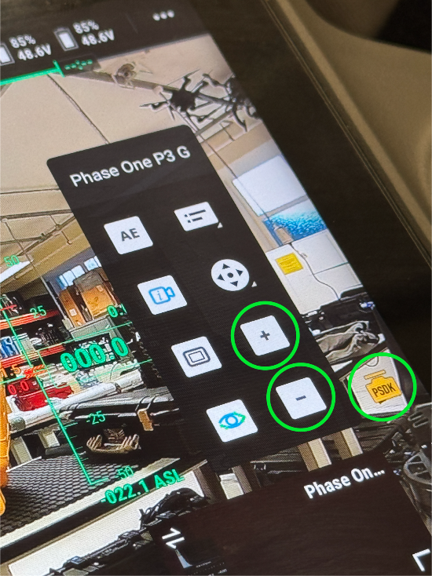
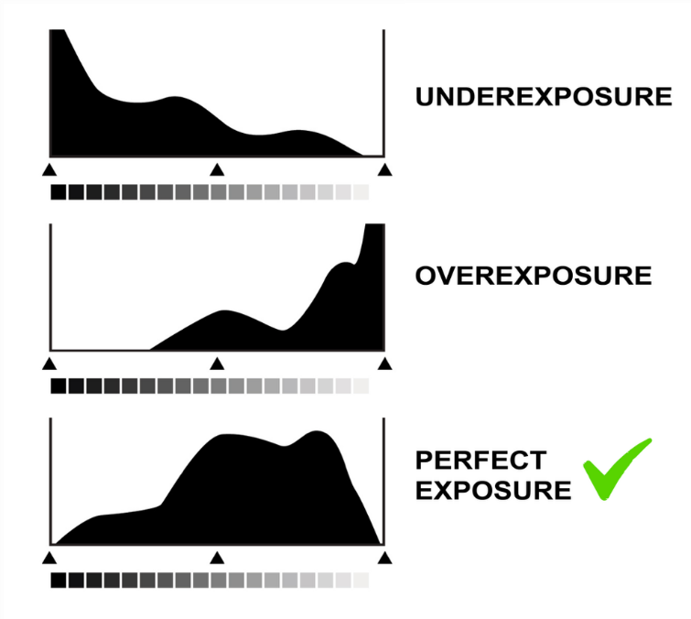
Example histogram and camera settings from a real operational scenario, captured under clear-sky conditions around solar noon:
+ and – buttons used to adjust exposure values. In this protocol, these buttons are used to increase or decrease the ISO value to achieve the correct histogram exposure.

